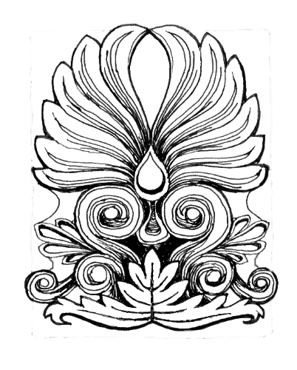
AUCKLAND DECORATIVE AND FINE ARTS SOCIETY INC

MEMBERSHIP FORM 2023

Name: ………………………………………………………………………………

Email:
……………………………………………………………………………….

Phone:
………………………………………………………………………………

Address:
…………………………………………………………………………….

……………………………………………………………………………………….

Preferred name for badge:
…………………………………..................................
Subscription: $190.00 for the full year or $95 for the first 4 lectures - half year.
PAYMENT: Subscriptions are due by February 19 by Internet banking or if you prefer, Direct Debit at your bank.
AkDFAS Account no 12 3042-0379470-00 (include full name and ref: Sub First 4, 2023)
For our records, please complete the form above and either send to our email address, or post to our P.O. Box.
Please note: If you have completed membership forms in the past, there is no need to fill in this form as we will have your records.
membershipakdfas@gmail.com
PO Box 128070 Remuera, Auckland

Thank you for your patience and loyalty during this very trying time. We very much look forward to seeing you at our next meeting and to enjoying a fantastic year of lectures.
Kind regards,

Ann Batten,
Membership Secretary, AkDFS

